**HW5 MATLAB code**

1.

T = 1/4;

N = 16;

n = 0:N-1;

hn = cos(2*pi*n*T);

wr = ones(1,N);

Hk = fft(hn.*wr);

W = @(f) exp(1j*pi*(N-1)*T*f).*sinc(N*T*f)./sinc(T*f)*N; % sinc(x)=sin(pi*x)/(pi*x) in MATLAB

Hk_theo = 1/2*W(n/(N*T)-1) + 1/2*W(n/(N*T)+1);

plot(n,abs(Hk),'o',n,abs(Hk_theo),'x');

title('Result oh H[k]');

xlabel('k'); ylabel('|H[k]|');

legend('FFT','Theoretical');

2.

%(a)

L = 64;

W = @(w) exp(-1j*w*(L-1)/2).*sin(w*L/2)./sin(w/2);

fs = 10000;

w = -pi:1/fs:pi;

W_a = W(w);

figure(1);

plot(w,abs(W_a));

xlim([-pi pi]);

title('Amplitude of W(e^{j\omega})');

xlabel('\omega'); ylabel('|W(e^{j\omega})|');

grid on

%(b)

A0 = 1;

A1 = 0.75;

theta0 = 0;

theta1 = 0;

w0 = 2*pi/6;

w1 = 2*pi/3;

V_b = A0/2*exp(1j*theta0)*W(w-w0)+A0/2*exp(-1j*theta0)*W(w+w0)+A1/2*exp(1j*theta1)*W(w-w1)+A1/2*exp(-1j*theta1)*W(w+w1);

figure(2);

plot(w,abs(V_b));

title('Amplitude of V(e^{j\omega}) for \omega_0 = 2\pi/6 and \omega_1 = 2\pi/3');

xlabel('\omega'); ylabel('|V(e^{j\omega})|');

xlim([-pi pi]);

grid on

%(c)

w0 = 2*pi/14;

w1 = 4*pi/15;

V_c = A0/2*exp(1j*theta0)*W(w-w0)+A0/2*exp(-1j*theta0)*W(w+w0)+A1/2*exp(1j*theta1)*W(w-w1)+A1/2*exp(-1j*theta1)*W(w+w1);

figure(3);

plot(w,abs(V_c));

title('Amplitude of V(e^{j\omega}) for \omega_0 = 2\pi/14 and \omega_1 = 4\pi/15');

xlabel('\omega'); ylabel('|V(e^{j\omega})|');

xlim([-pi pi]);

grid on

%(d)

w0 = 2*pi/14;

w1 = 2*pi/12;

V_d = A0/2*exp(1j*theta0)*W(w-w0)+A0/2*exp(-1j*theta0)*W(w+w0)+A1/2*exp(1j*theta1)*W(w-w1)+A1/2*exp(-1j*theta1)*W(w+w1);

figure(4);

plot(w,abs(V_d));

title('Amplitude of V(e^{j\omega}) for \omega_0 = 2\pi/14 and \omega_1 = 2\pi/12');

xlabel('\omega'); ylabel('|V(e^{j\omega})|');

xlim([-pi pi]);

grid on

%(e)

w0 = 2*pi/14;

w1 = 4*pi/25;

V_e = A0/2*exp(1j*theta0)*W(w-w0)+A0/2*exp(-1j*theta0)*W(w+w0)+A1/2*exp(1j*theta1)*W(w-w1)+A1/2*exp(-1j*theta1)*W(w+w1);

figure(5);

plot(w,abs(V_e));

title('Amplitude of V(e^{j\omega}) for \omega_0 = 2\pi/14 and \omega_1 = 4\pi/25');

xlabel('\omega'); ylabel('|V(e^{j\omega})|');

xlim([-pi pi]);

grid on

3.

%(a)

N = 64;

A0 = 1;

A1 = 0.75;

w0 = 2*pi/14;

w1 = 4*pi/15;

theta0 = 0;

theta1 = 0;

n = 0:N-1;

v = A0*cos(w0*n+theta0)+A1*cos(w1*n+theta1);

figure(1);

stem(n,v,'.');

title('v[n]');

xlabel('n'); ylabel('Amplitude');

xlim([0 N]);

%(b)

V = fft(v);

figure(2);

stem(n,real(V),'.');

title('Re\{V[k]\}');

xlabel('k,\omegaN/2\pi'); ylabel('Amplitude');

xlim([0 N]);

%(c)

figure(3);

stem(n,imag(V),'.');

title('Im\{V[k]\}');

xlabel('k,\omegaN/2\pi'); ylabel('Amplitude');

xlim([0 N]);

%(d)

figure(4);

stem(n,abs(V),'.');

title('|V[k]|');

xlabel('k,\omegaN/2\pi'); ylabel('Amplitude');

xlim([0 N]);

%(e)

figure(5);

stem(n,angle(V),'.');

title('\angleV[k]');

xlabel('k,\omegaN/2\pi'); ylabel('Radians');

xlim([0 N]);

%(f)

figure(6);

plot((0:1023)*2*pi/1024,abs(fft(v,1024)));

title('|V(e^{j\omega})|');

xlabel('\omega'); ylabel('Amplitude');

xlim([0 2*pi]);

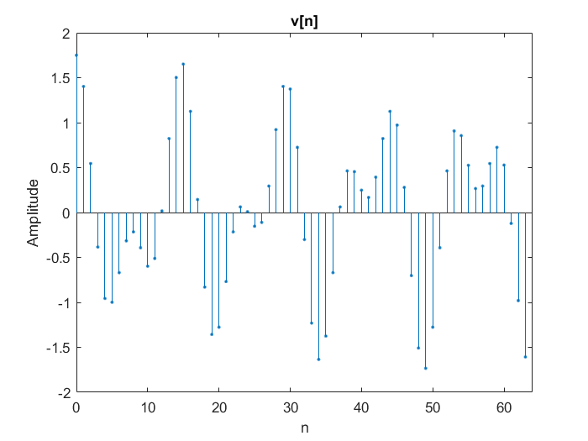

4.

T = 0.1;

N = 32;

n = (0:N-1)';

hn = cos(2*pi*n*T*1.1) + 0.07*cos(2*pi*n*T*2.9);

fs = 1/T;

N_fft = 256;

f = (-N_fft/2:N_fft/2-1)*fs/N_fft;

w_r = rectwin(N);

H = fft(hn.*w_r);

figure(1);

stem(n,abs(H),'.');

title('Amplitude of H[k]');

xlabel('k'); ylabel('|H[k]|');

figure(2);

plot(f,abs(fftshift(fft(hn.*w_r,N_fft))));

title('Amplitude of H[k]');

xlabel('f'); ylabel('|H[k]|');

w_hm = hamming(N);

figure(3);

subplot(2,2,1);

stem(n,hn,'.');

title('h[n]');

xlabel('n'); ylabel('h[n]');

subplot(2,2,2);

stem(n,w_hm,'.');

title('w_{hm}[n]');

xlabel('n'); ylabel('w_{hm}[n]');

subplot(2,2,3:4);

stem(n,hn.*w_hm,'.');

title('h[n]w_{hm}[n]');

xlabel('n'); ylabel('h[n]w_{hm}[n]');

H = fft(hn.*w_hm);

figure(4);

stem(n,abs(H),'.');

title('Amplitude of H[k]');

xlabel('k'); ylabel('|H[k]|');

figure(5);

plot(f,abs(fftshift(fft(hn.*w_hm,N_fft))));

title('Amplitude of H[k]');

xlabel('f'); ylabel('|H[k]|');

w_b = blackman(N);

figure(6);

subplot(2,2,1);

stem(n,hn,'.');

title('h[n]');

xlabel('n'); ylabel('h[n]');

subplot(2,2,2);

stem(n,w_b,'.');

title('w_b[n]');

xlabel('n'); ylabel('w_b[n]');

subplot(2,2,3:4);

stem(n,hn.*w_b,'.');

title('h[n]w_b[n]');

xlabel('n'); ylabel('h[n]w_b[n]');

H = fft(hn.*w_b);

figure(7);

stem(n,abs(H),'.');

title('Amplitude of H[k]');

xlabel('k'); ylabel('|H[k]|');

figure(8);

plot(f,abs(fftshift(fft(hn.*w_b,N_fft))));

title('Amplitude of H[k]');

xlabel('f'); ylabel('|H[k]|');

(a)

(b)

(c)

6.

f1 = 1*10^3;

f2 = 1.01*10^3;

fs = 2500;

T = 1/fs;

N = 1000;

n = 0:N-1;

vn = cos(2*pi*f1*n*T)+cos(2*pi*f2*n*T);

N_fft = 2^nextpow2(N);

V = fft(vn,N_fft);

figure(1);

stem(0:N_fft-1,abs(V),'.');

title('DFT of v[n] (N=1000,f_s=2500Hz)');

xlabel('k'); ylabel('V[k]');

N_fft = 16*2^nextpow2(N);

V = fft(vn,N_fft);

figure(2);

plot((-N_fft/2:N_fft/2-1)*fs/N_fft,abs(fftshift(V)));

title('DTFT of v[n] (N=1000,f_s=2500Hz)');

xlabel('f'); ylabel('V(f)');

w = bartlett(N)';

V_b = fft(vn.*w,N_fft);

figure(3);

stem(0:N_fft-1,abs(V_b),'.');

title('DFT of v[n] with Bartlett window (N=1000,f_s=2500Hz)');

xlabel('k'); ylabel('V[k]');

V_b = fft(vn.*w,N_fft);

figure(4);

plot((-N_fft/2:N_fft/2-1)*fs/N_fft,abs(fftshift(V_b)));

title('DTFT of v[n] with Bartlett window (N=1000,f_s=2500Hz)');

xlabel('f'); ylabel('V(f)');



